Complete Case Study 5-69, #1, #2, #3 on page 221-222. Show your calculations in your responses and submit your assignment in a word document file, single page, 12 font.
Madison Electric Pump Corporation manufactures electric pumps for commercial use. The company produces three models, designated as regular, advanced, and deluxe. The company uses a job-order cost accounting system with manufacturing overhead applied on the basis of direct-labor hours. The system has been in place with little change for 25 years. Product costs and annual sales data are as follows:

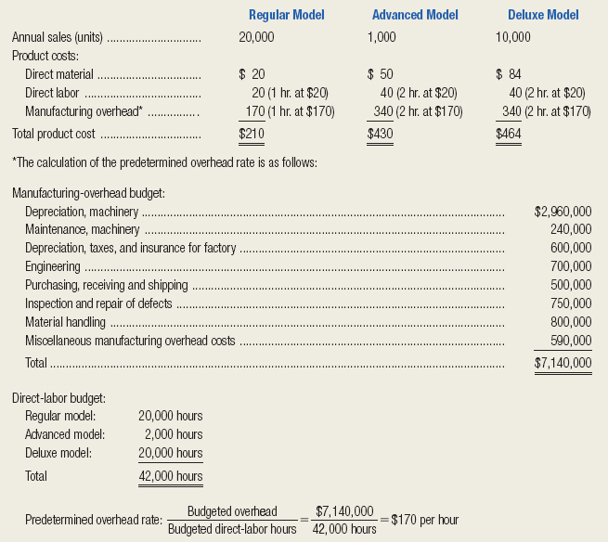
For the past 10 years, the company's pricing formula has been to set each product's target price at 110 percent of its full product cost. Recently, however, the regular-model pump has come under increasing price pressure from offshore competitors. The result was that the price on the regular model has been lowered to $220.
The company president recently asked the controller, “Why can't we compete with these other companies? They're selling pumps just like our regular model for $212. That's only two bucks more than our production cost. Are we really that inefficient? What gives?”

The controller responded by saying, “I think this is due to an outmoded product-costing system. As you may remember, I raised a red flag about our system when I came on board last year. But the decision was to keep our current system in place. In my judgment, our product-costing system is distorting our product costs. Let me run a few numbers to demonstrate what I mean.”

Getting the president's go-ahead, the controller compiled the basic data needed to implement an activity-based costing system. These data are displayed in the following table. The percentages are the proportion of each cost driver consumed by each product line
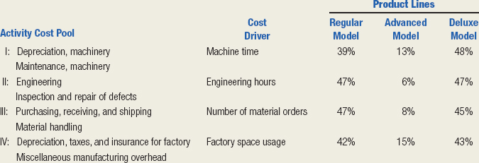

Required:
- Compute the target prices for the three pump models, based on the traditional, volume-based product-costing system.

- Compute new product costs for the three products, based on the new data collected by the controller. Round to the nearest cent.

- Calculate a new target price for the three products, based on the activity-based costing system. Compare the new target price with the current actual selling price for the regular model pump.

